Dear (insert friend/family member name here),
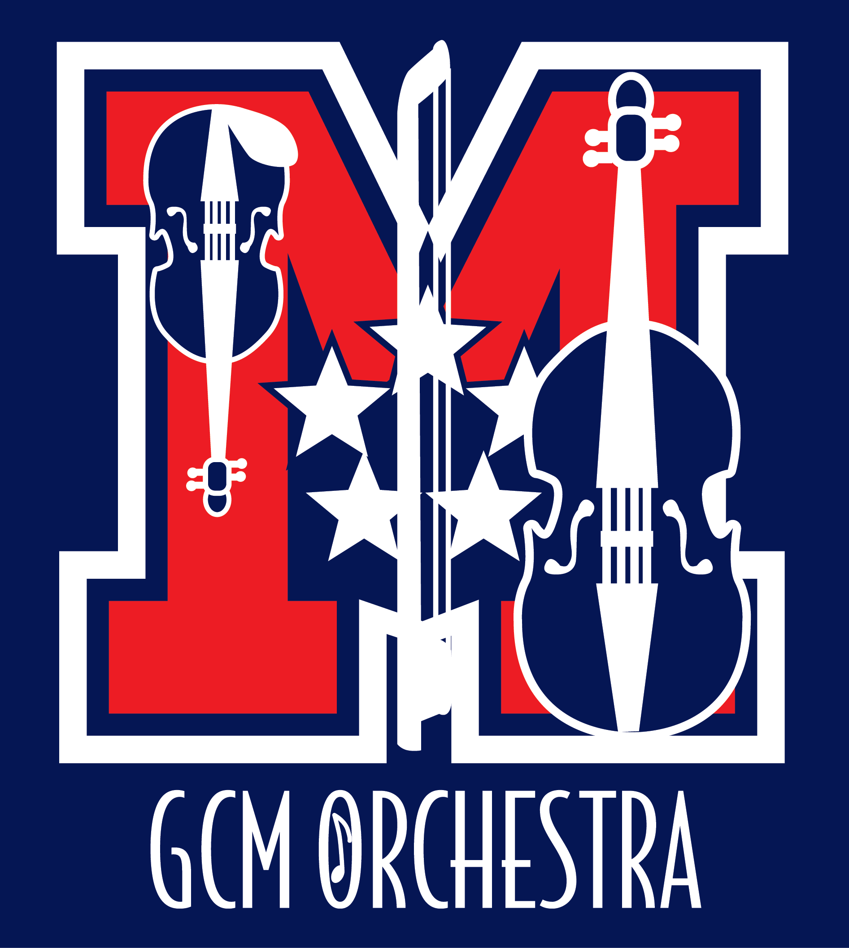
I am really excited to tell you about the orchestra program at my high school. As a member of the orchestra, I get to play along with 130 other student musicians at four concerts plus an assessment concert. We play various styles of music, as well as music from many cultures. I am very excited about being a member of the orchestra!

Marshall's orchestra program has increased dramatically over the past few years, over doubling the number of members and growing from two orchestra classes to four! The orchestras consistently earn high ratings at the District Assessment, and have played at appearances in Orlando, New York City, Chicago, Los Angeles and Nashville. Some of our students earn college scholarships based on their musicianship.
George C. Marshall High School Orchestras
7731 Leesburg Pike
Falls Church, VA 22043
703-714-5320

Orchestra Director
Catherine Bond

Principal
Jeffrey D. Litz

MOPA Board
Rafay Hassan
Cindy Nair
Joann Swift
Andrew Skinner

www.gcmorchestra.org
These achievements are not possible without a large financial investment beyond what is provided by the school system. Every year, our booster organization, MOPA, budgets for extras like guest conductors and sectional coaching, supplies and equipment, instrument repairs, guest speakers, professional development for our director, and many other things that make our orchestras so successful and fun. Last year, we were able to award a scholarship to a student musician for summer orchestra camp or private instruction, and this year we hope to increase the scholarship amount.
Will you help keep the orchestra's strings humming along? We have developed several levels of support for you to consider. Any amount would be greatly appreciated, and all donations are tax deductible. Please see the next page and determine which level of sponsorship is comfortable for you. If you are interested in attending one of our performances this year, we would love to have you! Our performance dates are:
November 1st at 7:00pm – Fall Concert
December 6th at 7:00pm – Winter Concert
February 28th at 7:00pm – Pre-Assessment Concert
June 6th at 7:00pm – Spring Concert and Awards

Thank you for your support.

Sincerely,
(insert Student name)

George C. Marshall HS Orchestra Sponsorship Program
Quarter Note $25 Half Note $50 Whole Note $75
Donors at these levels will be listed in our programs for the 2016-2017 school year, and your business name will appear on our website.

Sonata Level $100
Your business will receive mention in our programs and can insert a 1/4 page of camera-ready art in our programs for the 2016-2017 school year (4" X 2.5"). Your business name will appear on our website, with a link to your business website (if provided).

Suite Level $250
Your business will receive mention in our programs and can insert a 1/2 page of camera-ready art in our programs for the 2016-2017 school year (5.25" X 4"). Your business name will appear on our website, with a link to your business website (if provided).

Symphony Level $500
Your business will receive mention in our programs and can insert a full page of camera-ready art in our programs for the remaining 2016-2017 school year (5.25" X 8.25"). You may request a chamber orchestra concert performance for your business. (Date, time, & location subject to Orchestra Director's approval.) Your business name will appear on our website, with a link to your business website (if provided).

Marshall's Orchestras thank you for your tax-deductible contribution.

Yes, I would like to continue to be a Marshall Orchestra Sponsor
My contribution level is (circle one):
Quarter Note $25 | Half Note $50 | Whole Note $75
Sonata $100 | Suite $250 | Symphony $500

Would you prefer your gift to be anonymous? Yes ____ No ______
Your name (company): ______________________________________________________
Your Address: _____________________________________________________
Phone: ______________________ E-mail:_______________________________
Student who referred this Sponsorship: ___________________________________
Please attach camera-ready art (JPG) for program – for Sonata, Suite and Symphony sponsor levels, or email a digital copy to mdrafayhassan@yahoo.com.
Marshall Orchestra Parents Association is a 501(c)(3) organization; our tax ID is 30-0583035. Retain the upper portion as your receipt. Please make checks payable to MOPA.

