e

Dear (insert friend or family member name here),

Hello! I am excited to tell you about the orchestra program at my high school. As a member of the orchestra, I get to play with 130 other student musicians at four concerts plus our assessment. We play various styles of music from many cultures. Members of the orchestra visit elementary schools to encourage younger students to learn about music, and our performing orchestra plays for community organizations. The orchestra earns high ratings at the District Assessment, and some of our senior students receive college scholarships based on their musicianship.

Donations help make our program possible. Every year, our booster organization, MOPA, budgets for instructional enhancement, supplies and equipment, instrument repairs, guest speakers, professional development for our director, an annual banquet and awards ceremony, and a student scholarship for summer orchestra camp or private instruction.

Will you help keep our orchestra sound? We have developed several levels of support for you to consider. Any amount would be greatly appreciated, and all donations are tax deductible. Please see the next page to determine which level of sponsorship is comfortable for you.

If you are interested in attending one of our performances this year, we would love to have you! Our performance dates are:

October 20th at 7:00pm – Fall Concert
December 6th and 7th at 7:00pm – Winter Concert
February 21th at 7:00pm – Pre-Assessment Concert
May 22nd at 7:00pm – Spring Concert and Awards

Thank you for your support.

Sincerely,

(Insert student name)

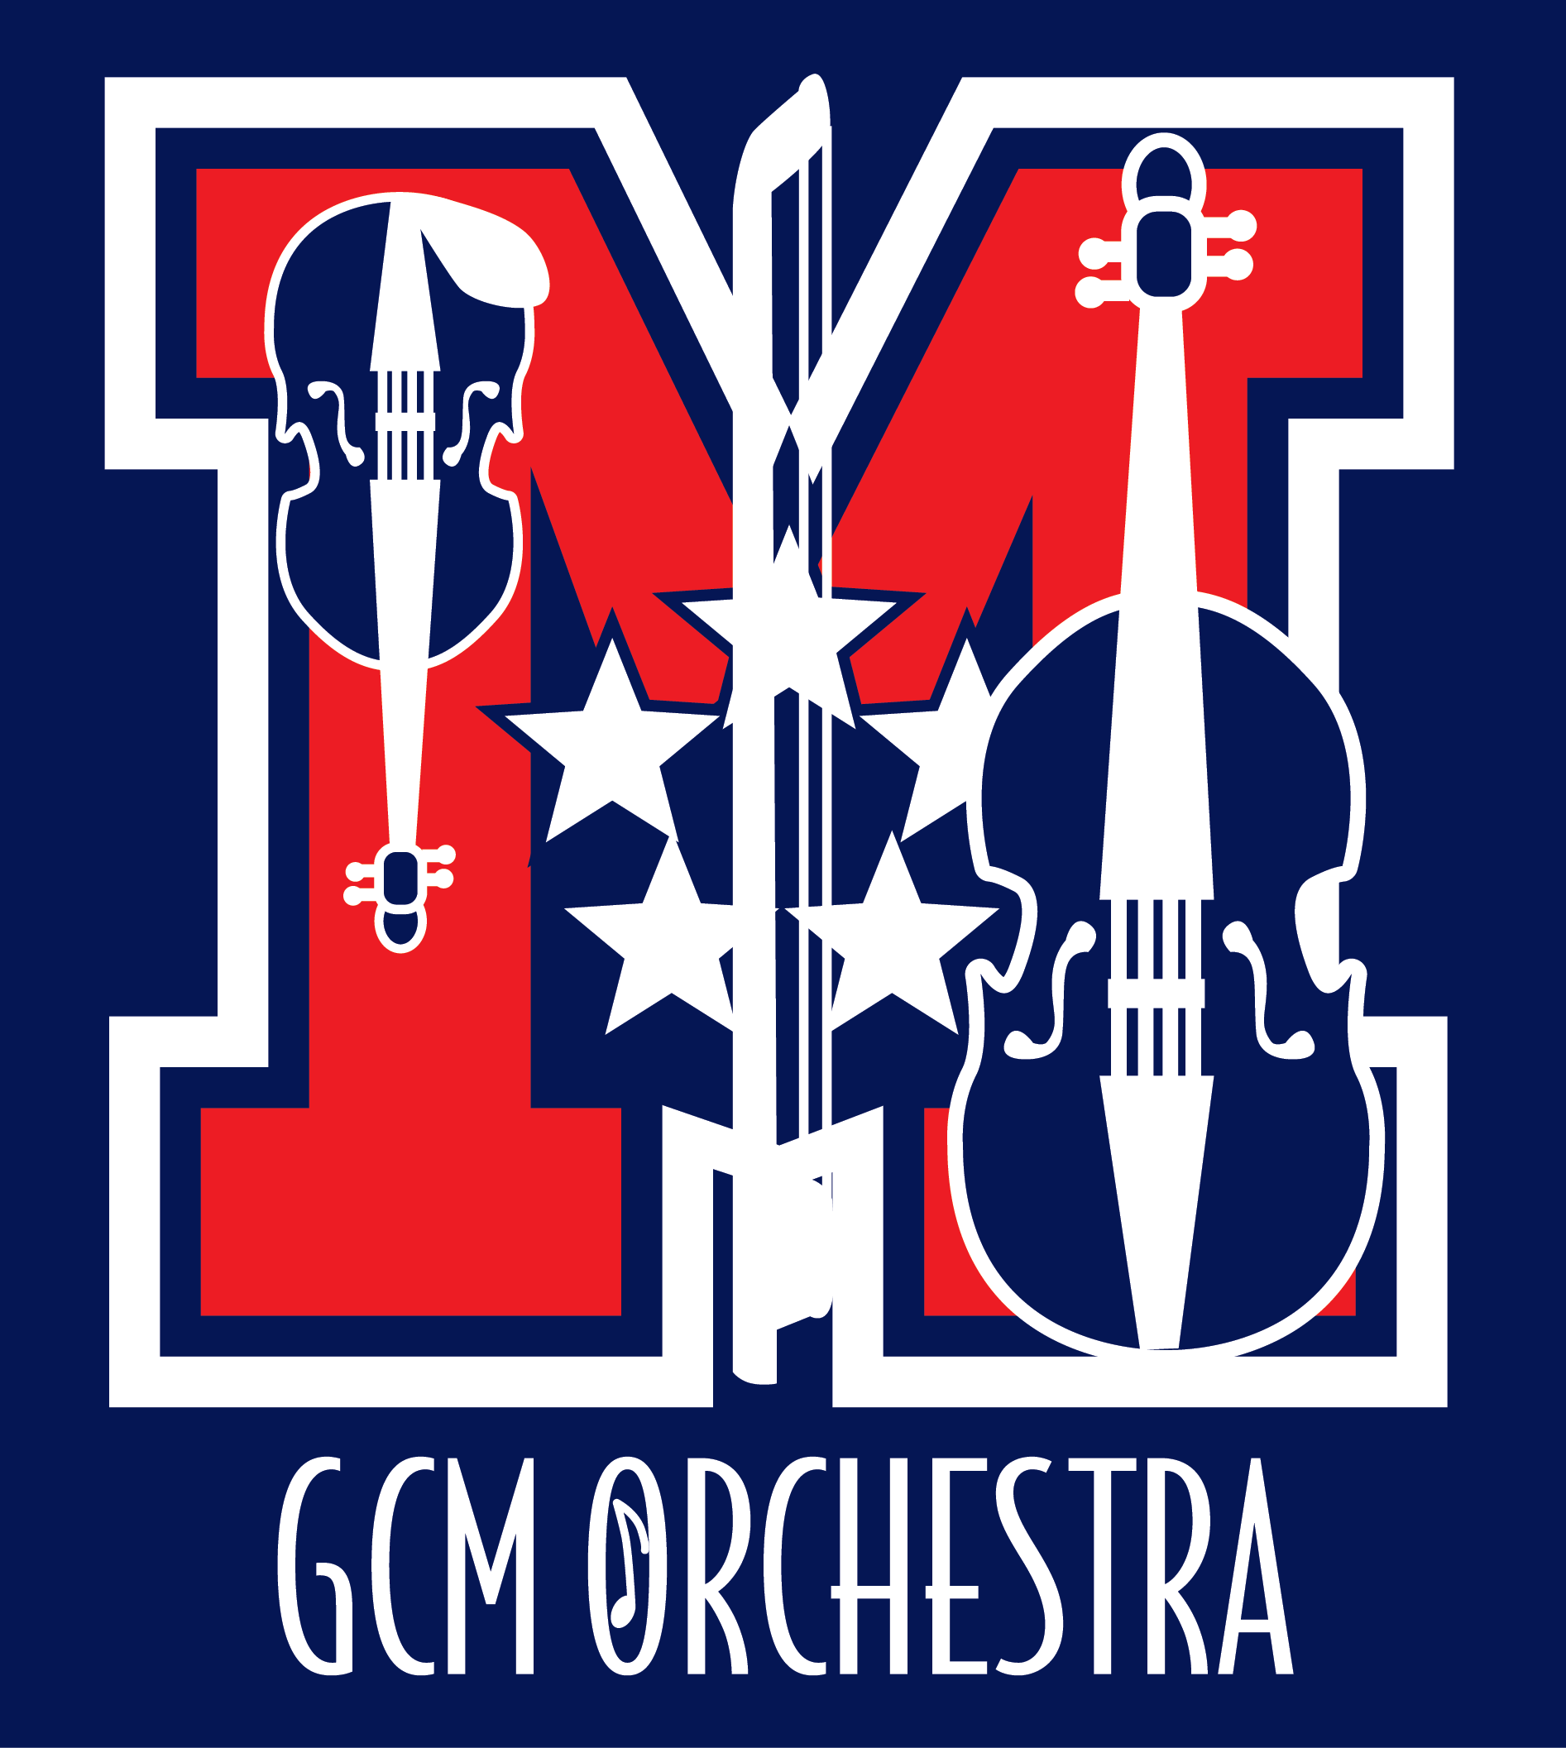

George C. Marshall
High School Orchestra
7731 Leesburg Pike
Falls Church, VA 22043

703-714-5320

www.gcmorchestra.org

Orchestra Director
Catherine Bond

Principal
Jeffrey D. Litz

MOPA Board
Andrew Skinner
Joann Swift
Gary and Kathe Peiffer
Gail Mulligan

George C. Marshall HS Orchestra Sponsorship Program

Quarter Note $25 Half Note $50 Whole Note $75
Donors at these levels will be listed in our programs for the 2017-2018 school year and your business name will appear on our website.

Sonata Level $100
Your business will receive mention in our programs and can insert a 1/4 page of camera-ready art in our programs for the 2017-2018 school year (4" X 2.5"). Your business name will appear on our website, with a link to your business website (if provided).

Suite Level $250
Your business will receive mention in our programs and can insert a 1/2 page of camera-ready art in our programs for the 2017-2018 school year (5.25" X 4"). Your business name will appear on our website, with a link to your business website (if provided).

Symphony Level $500
Your business will receive mention in our programs and can insert a full page of camera-ready art in our programs for the 2017-2018 school year (5.25" X 8.25"). You may request a chamber orchestra concert performance for your business. (Date, time, & location subject to Orchestra Director's approval.) Your business name will appear on our website, with a link to your business website (if provided).

Marshall Orchestra Parents Association is a 501(c)(3) organization; our tax ID is 30-0583035. Retain the upper portion as your receipt. Please make checks payable to MOPA. Thank you for your tax deductible donation!
Please attach camera-ready art (JPG) for program – for Sonata, Suite and Symphony sponsor levels, or email a digital copy to lisa.treichler@gmail.com.

Yes, I would like to be a Marshall Orchestra Sponsor
Quarter Note $25 | Half Note $50 | Whole Note $75
Sonata $100 | Suite $250 | Symphony $500
Would you prefer your gift to be anonymous? Yes ______ No ________
Your name (company): _______________________________________________________
Your address: ______________________________________________________________
Phone: ______________________ E-mail:________________________________________
Student who referred this Sponsorship: ____________________________________________

