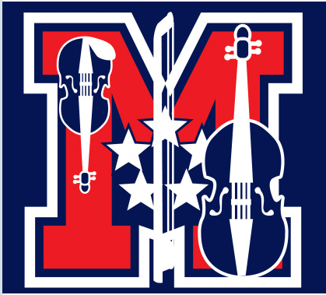
MOPA Orchestra Student Enrichment Scholarship
Submission Deadline: Tuesday, May 14, 2019

The Marshall Orchestra Parents Association (MOPA) is awarding scholarships to George C. Marshall High School Orchestra students enrolled in an orchestra class during the 2019/20 academic year.

The MOPA Scholarships will be awarded to students to help cover the cost for orchestra enrichment programs such as summer camps or additional training. Applicants should demonstrate responsibility, character, and leadership during their high school orchestra career. Scholarship checks will be made out to the program, camp, or instructor. Scholarship checks must be dispersed by December 31, 2019.

Scholarship Criteria:

In order to apply for the MOPA Scholarship, applicants must meet the following eligibility criteria:
- Be enrolled in a George C. Marshall High School Orchestra class during the 2019/20 academic year
- Be a current high school freshman, sophomore or junior
- Earn a minimum 2.5 grade point average on a scale of 4.0
- Begin an orchestra enrichment program between the May 1st to December 31st, 2019
The applicant must submit
- a complete application form, and
- an essay (250 words or less) explaining how the enrichment program will benefit their orchestra learning.
Complete application must be submitted no later than Tuesday, May 14, 2019 via e-mail to MOPA4U@gmail.com.
MOPA President
MOPA4U@gmail.com

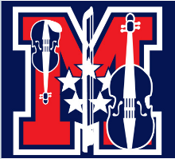

Application Form: 2019 MOPA Scholarship
Deadline Tuesday, May 14, 2019

Applicant Name:Click or tap here to enter text.
Address:Click to enter # Street, City, State, Zipcode.
Home Phone:Click to enter (XXX)-XXX-XXXX. Cell Phone:(XXX)-XXX-XXXX
E-mail:Click or tap here to enter text.
List high school orchestra classes you have completed:
Choose the orchestra level | Choose the school year.
Choose the orchestra level | Choose the school year.
Choose the orchestra level | Choose the school year.
Current Grade Level: Choose the grade.
Grade Point Average (GPA): Click or tap here to enter text.
Will you be enrolled in a Marshall Orchestra class during the 2019/20 academic year? Yes ☐ No ☐
List type of enrichment program you are planning to begin this calendar year:
Name of Program | Cost | Date
Essay detailing how this scholarship enriches your orchestra learning is attached. Yes ☐
Acknowledgement:
I have read the requirements pertaining to this application. I have reviewed the application and to the best of my knowledge, all information is accurate.

Click to enter a date.
Signature of Applicant Date

Click to enter a date.
Signature of Parent or Guardian Date

