Dear (insert vendor name here),
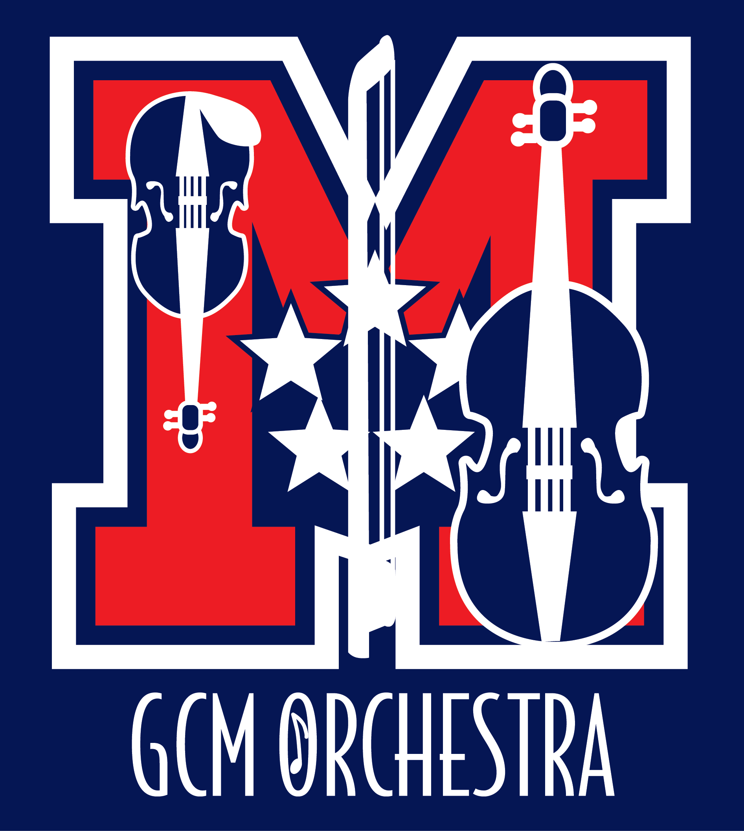
Thank you for the excellent service you provide to my family, our community, and me. We are lucky to live in such a vibrant community that boasts businesses like yours, as well as terrific opportunities for students like me.
I participate in one of the community’s more rewarding opportunities: The George C. Marshall High School Orchestra. As a member of the orchestra, I work with 130 other talented musicians to improve myself and provide cultural enrichment to our community.
George C. Marshall High School Orchestras
7731 Leesburg Pike
Falls Church, VA 22043
703-714-5320

Orchestra Director
Catherine Bond

Principal
Jeffrey D. Litz

MOPA Board
Rafay Hassan
Cindy Nair
Joann Swift
Andrew Skinner

www.gcmorchestra.org

Marshall's orchestra program has nearly doubled its number of members over the past few years, and has grown from two orchestra classes to four! The orchestras consistently earn high ratings at the District Assessment, and have played at appearances in Orlando, New York City, Chicago, Los Angeles and Nashville. Some of our students earn college scholarships based on their musicianship.
These achievements are not possible without a large financial investment. Every year, our booster organization, MOPA, budgets for instructional enhancement including guest conductors and sectional coaching, supplies and equipment, instrument repairs, guest speakers, professional development for our director, an annual banquet and awards ceremony, and many other incidental expenses. Last year MOPA awarded a scholarship to a student musician for summer orchestra camp or private instruction, and we hope to increase that scholarship amount this year!
Will you help keep the orchestras’ strings humming along? We have developed several levels of support for you to consider. Any amount would be greatly appreciated, and all donations are tax deductible. Please see the next page to determine which level of sponsorship is comfortable for you. If you are interested in attending one of our performances this year, we would love to have you! Our performance dates are:
November 1st at 7:00pm – Fall Concert
December 6th at 7:00pm – Winter Concert
February 28th at 7:00pm – Pre-Assessment Concert
June 6th at 7:00pm – Spring Concert and Awards

Thank you for your support.

Sincerely,
(insert Student name)

George C. Marshall HS Orchestra Sponsorship Program
Quarter Note $25 Half Note $50 Whole Note $75
Donors at these levels will be listed in our programs for the 2016-2017 school year, and your business name will appear on our website.

Sonata Level $100
Your business will receive mention in our programs and can insert a 1/4 page of camera-ready art in our programs for the 2016-2017 school year (4" X 2.5"). Your business name will appear on our website, with a link to your business website (if provided).

Suite Level $250
Your business will receive mention in our programs and can insert a 1/2 page of camera-ready art in our programs for the 2016-2017 school year (5.25" X 4"). Your business name will appear on our website, with a link to your business website (if provided).

Symphony Level $500
Your business will receive mention in our programs and can insert a full page of camera-ready art in our programs for the remaining 2016-2017school year (5.25" X 8.25"). You may request a chamber orchestra concert performance for your business. (Date, time, & location subject to Orchestra Director's approval.) Your business name will appear on our website, with a link to your business website (if provided).

Marshall's Orchestras thank you for your tax-deductible contribution.

Yes, I would like to continue to be a Marshall Orchestra Sponsor
My contribution level is (circle one):
Quarter Note $25 | Half Note $50 | Whole Note $75
Sonata $100 | Suite $250 | Symphony $500

Would you prefer your gift to be anonymous? Yes ____ No ______
Your name(company): _______________________________________________________
Your Address: _____________________________________________________
Phone: ______________________ E-mail:_______________________________
Please attach camera-ready art (JPG) for program – for Sonata, Suite and Symphony sponsor levels.
Marshall Orchestra Parents Association is a 501(c)(3) organization; our tax ID is 30-0583035. Retain the upper portion as your receipt. Please make checks payable to MOPA.

